JUDUL: 12-15 Kata (Maiandra GD 14 pt) spasi 1

First Author*¹, Second Author², Third Author³ (10 pt)
^{1,3}Insitituti, kota, Negara, email: (9 pt)

Article Info |  | ABSTRACT (10 pt)
Article history:  Received Jun 12, 201x  Revised Aug 20, 201x  Accepted Aug 26, 201x |  | Articles must include an abstract of 200 – 250 words or fewer. The abstract should not repeat the information already present in the title. The abstract should be written in English. Articles must include an abstract of 200 – 250 words or fewer. The abstract should not repeat the information already present in the title. The abstract should be written in English. Articles must include an abstract of 200 words or fewer. The abstract should not repeat the information already present in the title. The abstract should be written in English. Articles must include an abstract of 200 – 250 words or fewer. The abstract should not repeat the information already present in the title. The abstract should be written in English. Articles must include an abstract of 200 words or fewer. The abstract should not repeat the information already present in the title. The abstract should be written in English. Articles must include an abstract of 200 – 250 words or fewer. The abstract should not repeat the information already present in the title. The abstract should be written in English. (9 pt).
Keywords:
Maximum of 5 keywords spareted by comma (,).
Keywords:  Maximum of 5 keywords spareted by comma (,). |  | ABSTRAK (10 pt)  Abstrak dibuat dalam dua bahasa, yaitu Bahasa Indonesia dan Bahasa Inggris. Edisi B. Indonesia merupakan terjemahan dari abstrak dalam Bahasa Inggris dengan format sama seperti abstrak dalam Bahasa Inggris
How to Cite:
Last name-1, Initial First and Middle name-1., Last name-2, Initial First and Middle name-2., & Last name-3, Initial First and Middle name-3. (2019). Title Title Title Title. AB-JME, X(X), XX-XX.

INTRODUCTION (12 pt)
Al-Bahjah Journal of Mathematics Education is open to the public, researchers, academics, practitioners and observers in the field of education. This journal is a publication that contains research results, development of innovative and relevant research and related conceptual studies and/or developments in the field of Education.
The introduction includes the background on a problem as well as the urgency and rationalization of research activities. Research objectives and references (relevant literature or research) need to be included in this section, the relationship with previous research and research novelty, the relationship with the justification of research urgency, alternative solutions and solutions chosen. The citation method needs to be done correctly with the name of the author, source, year of publication according to the APA style using the Mendeley application. For example (Hamidah, 2022).
- Reference sources refer to the proportion of the last 10 years and primary literature. The problems and objectives as well as the usefulness of the research are written narratively in paragraphs. There is no need to include an operational definition, if it is deemed necessary to include an operational definition it can be written in an integrated manner.
- The introduction is written in Maiandra GD-12, upright with 1.5 spacing. Subtitles can be done according to the examples given.
METHOD (12 pt)
The Methods sections should be brief, but they should include sufficient technical information to allow the experiments to be repeated by a qualified reader. Only new methods should be described in detail. Cite previously published procedures in References.
Tables and Figures are presented center, as shown below and cited in the manuscript.
Table 1. Number of students based early mathematical ability
PAM | Experiments | Control
High | 11 | 12
Medium | 53 | 44
Low | 9 | 10
Total | 73 | 66

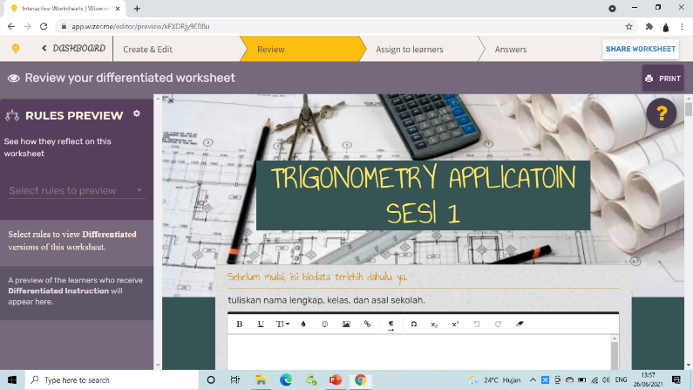
Figure 1. Worksheet
RESULTS AND DISCUSSION (12 pt)
The Results should include the rationale or design of the experiments as well as the results of the experiments. Results can be presented in figures, tables, and text. The Results should include the rationale or design of the experiments as well as the results of the experiments. Results can be presented in figures, tables, and text.
The Discussion should be an interpretation of the results rather than a repetition of the Results. The Discussion should be an interpretation of the results rather than a repetition of the Results. The Discussion should be an interpretation of the results rather than a repetition of the Results. The Discussion should be an interpretation of the results rather than a repetition of the Results. The Discussion should be an interpretation of the results rather than a repetition of the Results.
The Discussion should be an interpretation of the results rather than a repetition of the Results. The Discussion should be an interpretation of the results rather than a repetition of the Results. The Discussion should be an interpretation of the results rather than a repetition of the Results.

CONCLUSION (12 pt)
The Conclusion should contain the confirmation of the problem that has been analyzed in result and discussion section. The Conclusion should contain the confirmation of the problem that has been analyzed in result and discussion section. The Conclusion should contain the confirmation of the problem that has been analyzed in result and discussion section.
REFERENCES (12 pt)
The references that used in this articles must fit into the format below.
Author’s Name. (Year). Title of Articles. Type of Source, page. City: Publisher. (Adapted from APA Citation Style)

Book:
Soenarjo, R. J. (2008). Matematika 5. Jakarta: Departemen Pendidikan Nasional.

Thesis, Disertation, Research Report:
Prahmana, R.C.I. (2012). Pendesainan Pembelajaran Operasi Bilangan Menggunakan Permainan Tradisional Tepuk Bergambar Untuk Siswa Kelas III Sekolah Dasar (SD). Unpublished Thesis. Palembang: Sriwijaya University.

Article in Journal:
Hamidah, I, Susilawati. (2022). Pengembangan Bahan ajar Barisan dan deret Berbasis Mobile Learning Berbantuan Microsoft Kaizala Berorientasi Kemampuan Berpikir Kreatif Siswa. Journal of Research in Science and Mathematics Education (J-RSME), 1(2), 64-77.

Article in Newspaper:
Pitunov, B. (13 December 2002). Sekolah Unggulan ataukah Sekolah Pengunggulan? Majapahit Pos, page 4 & 11.

Internet:
Hitchcock, S., Carr, L., & Hall, W. (1996). A Survey of STM Online Journals, 1990-1995: The Calm before the Storm, (Online), (http://journal.ecs.soton.ac.uk/survey/survey.html), diakses 12 Juni 1996

